The 21 Indispensable Qualities of a Leader Book:
MRS will provide copies of the 21 Indispensable Qualities of a Leader, author John C. Maxwell to all class participants, with enough extra copies for our COR. Participants will keep their books.
- Our facilitator will assign readings from various chapters (3-4 pages) of the book to small group teams.
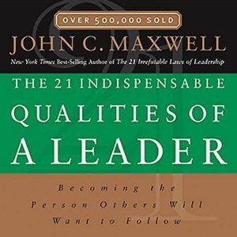 | Facilitate Book Discussions: The book discussions will serve as an enabler to enrich the program content and have participants gain awareness of what effective leaders do. It will help readers become more effective leaders from the inside out. The readings will highlight the 21 essential leadership qualities that include "Reflecting On It" and "Bringing It Home" sections which help readers integrate and apply each day's material.
To support transfer of learning, small groups will be asked to highlight the learning for sections of the book, i.e., leading class discussions, and to generalize the application to their teams and to the larger organization. Specifically, during the instructor-led sessions, participants will work in small groups to share their review of the chapters and assess the applicability to 3 leader competencies. Also, group participants will share personal stories that relate to the chapter’s content and select one of the stories to convey to the class during small group readouts. A key benefit of this approach is to help participants generalize the applicability of the book discussion to their role as leaders in their Agency or teams.
The facilitator will support processing of key points and tying them to the core leader competencies for this course.

