INITIATE PHASE
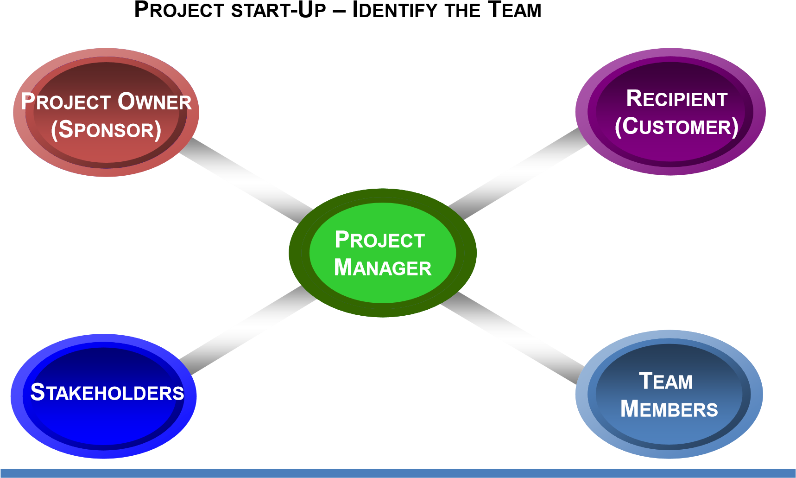
PROJECT CHARTER TEMPLATE
PROJECT NAME
PROJECT SPONSOR
PROJECT MANAGER | CUSTOMER
PROJECT STAKEHOLDERS
STAKEHOLDER(S) RESPONSIBILITIES
BUSINESS OBJECTIVES
PROJECT OBJECTIVES (SMART)
DELIVERABLES
PROJECT COMPLETION DATE | BUDGET
ASSUMPTIONS
LINKAGE TO STRATEGIC OBJECTIVES
AGREEMENT LINE PROJECT SPONSOR | PROJECT MANAGER
138

RISK MANAGEMENT PLANNING
Questions to Ponder: What are their Probabilities and their Impacts?
- Are the Customer Requirements well understood?
- Are costs and time estimate detailed or top down?
- How likely is the Project Scope to change?
- Will Resources be dedicated to the project or on part time basis?
- Will Key Resources be reassigned or lost to the project?
- Will deadlines be pushed out by the customer or others?
- Will the customer be responsive and meet key milestones?
- Will we have technical problems
- Have we addressed the effects of single-point estimates and path convergence?
Low
Impact
Probability
Low
High
High
High Risk
Low Risk
Moderate
Risk
R
ISK
A
NALYSIS
O
PTIONS
1.
Avoid
2.
Accept
3.
Mitigate
4.
Transfer

139
INITIATE PHASE – PLANNING A PROJECT KICK-OFF MEETING
DOCUMENT PREPARATION FORMATION
PROJECT NAME | PROJECT MANAGER |  | DATE PREPARED
SPONSOR INFORMATION
SPONSOR |  | CONTACT INFORMATION
ATTENDEES
NAME |  | E-MAIL ADDRESS
M
EETING
I
NFORMATION
D
ATE
S
TART
T
IME
E
ND
T
IME
L
OCATION
M
EETING
P
URPOSE
A
GENDA
I
TEMS
P
RESENTER
T
IME
Welcome & Introductions
Establish Ground Rules
Executive Perspective
Project Overview:
Project Objectives
Project Charter
Proposed Solution
Project Deliverables
Project Accomplishments To Date
Project Schedule and Major Milestones (A)
Team Roles & Responsibilities (B)
Communication Plan (C)
Summary and Close
140

PLAN PROJECT
WORK BREAKDOWN STRUCTURE TEMPLATE
(B) PROJECT TASK WORKSHEET ____________ ASSIGNED PERSON __________
Task | Subtasks | Activities | Time | Estimate | Deliverables | Costs | Comments

141

PLAN PROJECT TEMPLATE
PROJECT SCHEDULE AND MAJOR MILESTONES |  |  | (A)
Tasks and Milestones Baseline Date |  |  | Cost Owner Completion Date
1.0
1.1
1.2
1.2.1 (Milestone)
1.2.2 (Milestone)
2.0
2.1 (Milestone)
3.0
3.1 (Milestone)
3.2 (Milestone)
4.0
4.1 (Milestone)
4.2
4.2.1 (Milestone)
4.2.2 (Milestone)

142

EXECUTE PROJECT
STATUS REPORTING TEMPLATE

W
EEKLY
S
TATUS
R
EPORT
(
C
)
To: ____________________________________________________
From: ____________________________________________________
Project Name: ____________________________________________________
For Week
Ending
:
____________________________________________________
A
CTIVITIES
AND
A
CCOMPLISHMENTS
THIS
WEEK
P
LANS
FOR
WEEK
E
NDING
__________
C
HANGES
TO
T
ARGET
D
ATES
T
ASKS
R
EVISED
T
ARGET
D
ATE
A
SSUMPTIONS
I
SSUES
RISKS
List the week’s activities and accomplishments for this project. Refer
to WBS when reporting accomplishments, plans, and issues.
1.
_____________________________
2.
_____________________________
3.
_____________________________
List the next week’s objectives and significant activities for this project
1.
_____________________________
2.
_____________________________
3.
_____________________________
List any new, changed, or significant target dates
List any assumptions.
List any issues (new or open) that require an action plan.
List any new or continuing risks associated with the project.

143

CHANGE CONTROL REQUESTTEMPLATE - SAMPLE
D
OCUMENT
P
REPARATION
I
NFORMATION
P
ROJECT
N
AME
P
REPARED
B
Y
D
ATE
P
REPARED
P
ROJECT
ID
P
ROPOSED
C
HANGE
C
HANGE
D
ESCRIPTION
–
ble the team to
Define the desired change in sufficient detail to ena
evaluate it. Identify all WBS elements affected by the change.
R
EASON
FOR
C
HANGE
–
Describe why this change is necessary or desirable
S
CHEDULE
AND
B
UDGET
I
MPACT
–
d cost to
State the effect on the project schedule an
ell as overall
complete this change. Include duration and cost of the specific change as w
impact, if known.
A
SSUMPTIONS
–
List
any business and technical assumptions.
A
UTHORIZATION
–
P
ROJECT
MANAGER
Name
Signature
Phone
Date
A
UTHORIZATION
–
F
UNDING
S
PONSOR
Name
Signature
Phone
Date
144

145
Are there deliverables outstanding?
Are there any internal outstanding commitments?
Have all costs been appropriately charged to the project?
Has the charge number for accounting been closed?
Have all tasks been completed?
Has management been notified regarding availability of project personnel?
Has excess project material been dealt with?
Has the Project Plan been achieved with all supporting information?
Have suppliers been notified regarding any outstanding commitments?
Are all stakeholders aware of project closeout?
Has the project been transitioned to operations and support?
Project – Check off
Have your take good care of high performing project team members
Have project team members been appropriately rewarded?
Was there a project celebration?
Was the celebration successful?
Personnel Internal
Is a process in place for maintaining the customer relationship?
Have vendors and subcontractors been advised of project status and of future opportunities?
External Issues
Project Closeout Checklist - Template
Document Preparation Information
Project Name Prepared By Date Prepared
Close Phase

